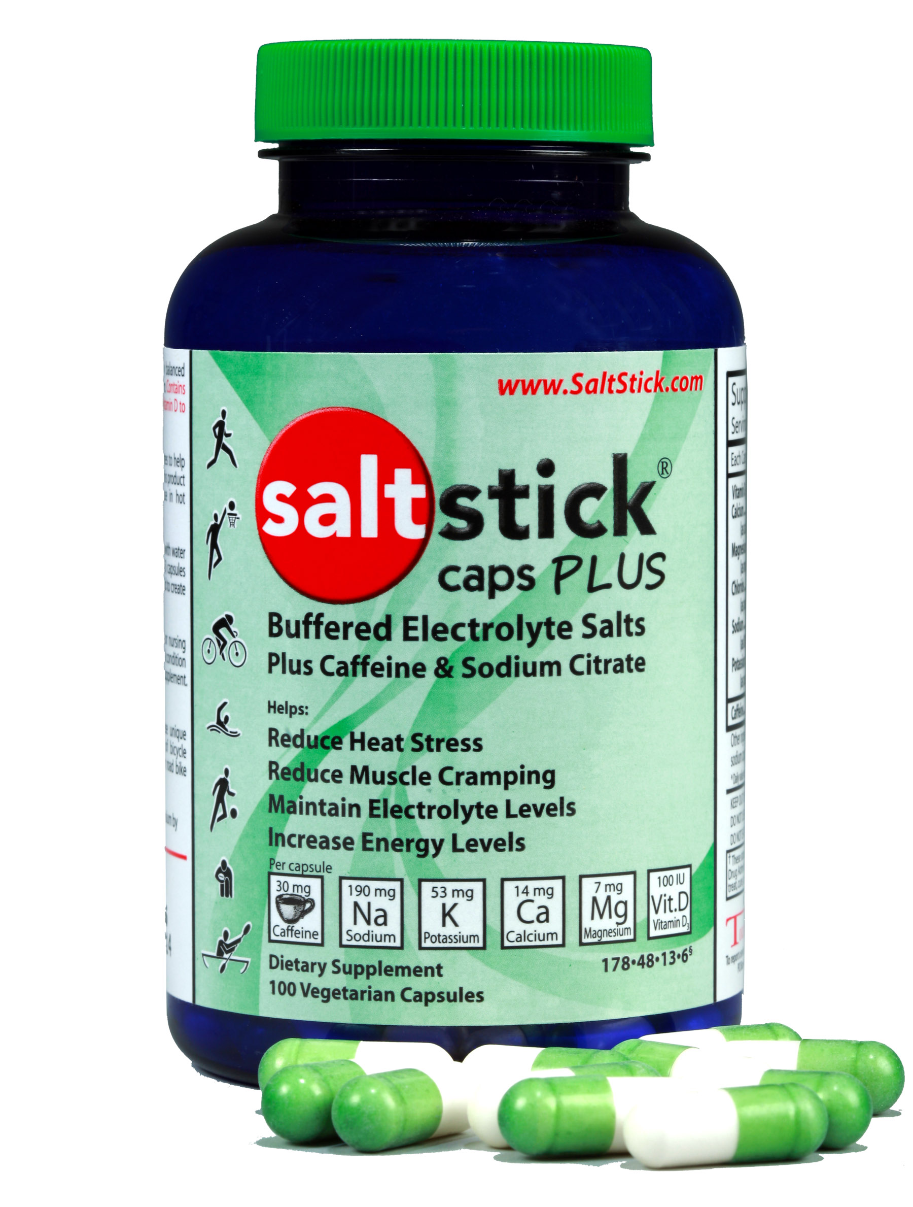
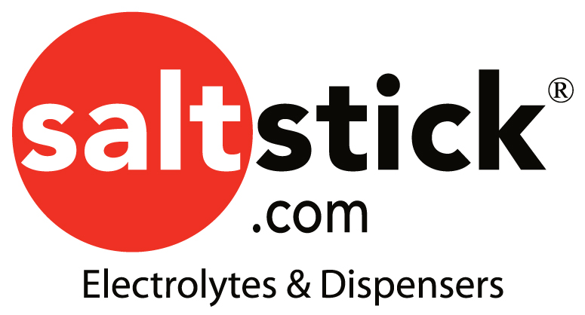
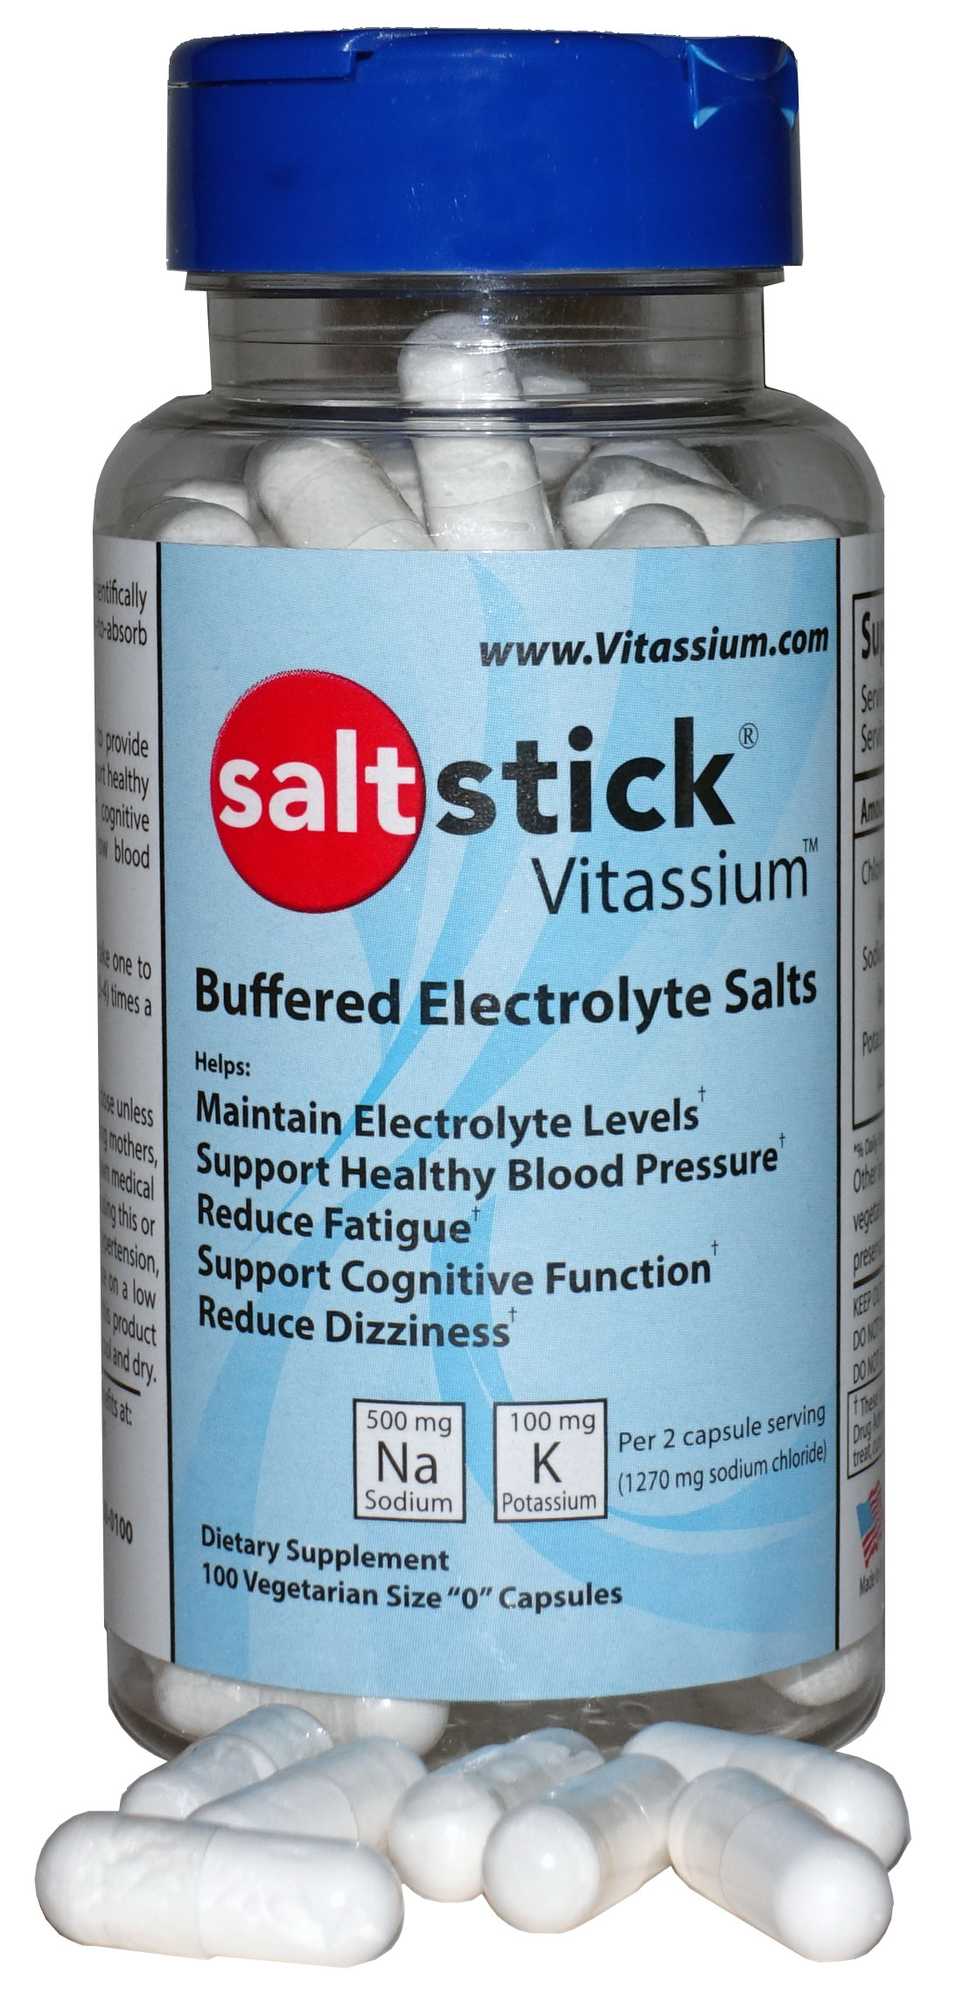
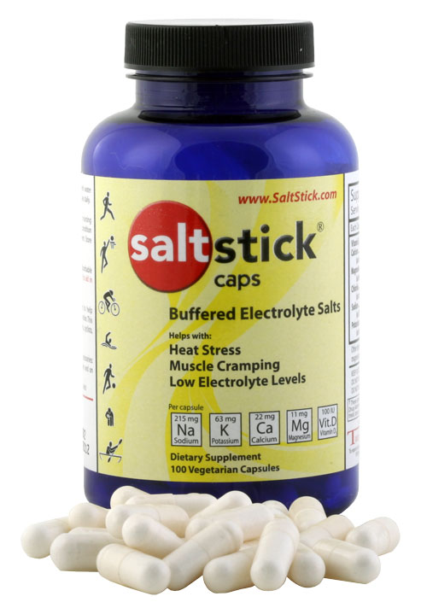
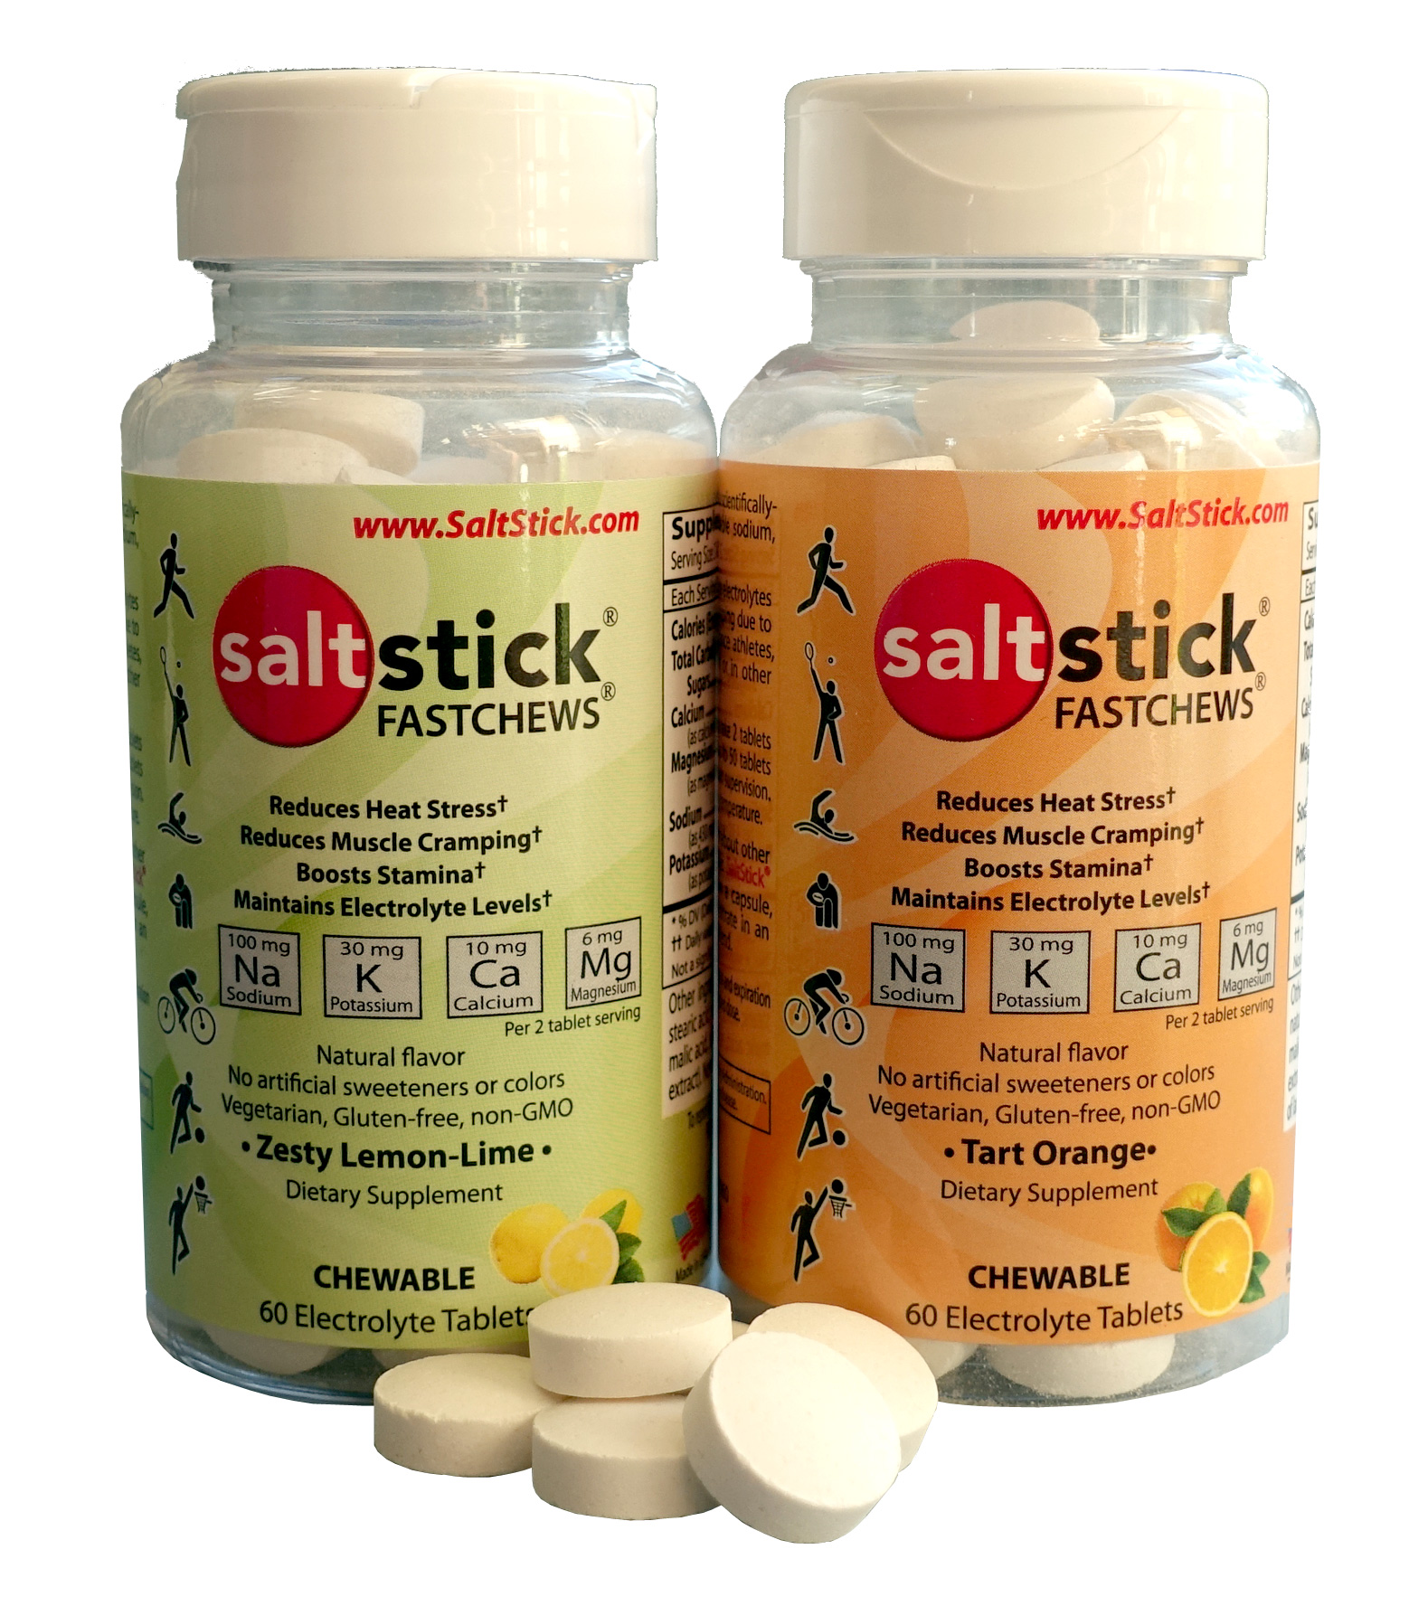

SaltStick® Caps, Caps PLUS, Fastchews & Vitassium:

The Most Comprehensive Electrolyte Supplements

- Helps Support Blood Pressure, Reduce Fatigue, Muscle Cramping and Heat Stress, Maintain Electrolyte Levels, Boost Stamina.
- SaltStick Caps: The ONLY electrolyte capsule that is formulated to closely resemble the electrolyte profile lost in sweat.
- SaltStick Vitassium: The only electrolyte capsule designed to support those with POTS
- Caps PLUS: The ONLY electrolyte capsule to feature 30 mg of caffeine for more energy and sodium citrate to soothe the stomach
- Vegetable-based non-GMO capsule or tablet composition; Bio-available active ingredients. Made in USA under cGMP standards.
- Tested not to contain any banned substances.
- Contains only WHAT YOU NEED. No herbal, trace, questionable components added. Fastchews feature natural flavors.

How do SaltStick® products compare? Cost effective, bioavailable, and a full spectrum of electrolytes in convenient forms.
Product | Per Capsule or Unit |  |  |  | Ave. Cost | Capsule
Product | Sodium (mg) | Potassium (mg) | Magnesium (mg) | Calcium (mg) | per capsule  or Unit | Material or Format
Sweat (per 315mL) | 220 | 63 | 8 | 16 | ---
SaltStick® Caps | 215 | 63 | 11 | 22 | $ 0.22 | Veggie Cap
SaltStick® Caps PLUS caffeine* | 190 | 53 | 7 | 14 | $ 0.30 | Veggie Cap
SaltStick® FASTCHEWS | 50 | 15 | 3 | 5 | $ 0.25 | Chewable Tab
SaltStick® Vitassium® | 250 | 50 | 0 | 0 | $ 0.22 | Veggie Cap
Base salt | 290 | 3 | 12 | 3 | $ 0.13 | Powder
ElectroMIX (Emergen-C) | 0 | 430 | 120 | 100 | $ 0.29 | Powder
Endurolytes | 40 | 25 | 25 | 50 | $ 0.18 | Veggie Cap
Endurolytes Extreme | 120 | 75 | 20 | 40 | $ 0.21 | Veggie Cap
Gatorade Gatorlyte | 780 | 400 | 35 | 0 | $ 0.75 | Powder
Gatorade Endurance | 200 | 90 | 0 | 0 | $ 0.50 | Drink
Gatorade Original | 110 | 30 | 0 | 0 | $ 0.40 | Drink
Heed (Hammer) | 45 | 25 | 32 | 60 | $ 0.94 | Powder
Nuun | 360 | 100 | 25 | 13 | $ 0.54 | Tablet
Perform | 190 | 10 | 6 | 0 | $ 0.75 | Drink
Pickle Juice | 820 | 70 | 0 | 0 | $ 1.67 | Drink
Roctane Gu Capsules | 140 | 0 | 9 | 0 | $ 0.16 | Veggie Cap
Skratch | 360 | 40 | 40 | 50 | $ 1.03 | Powder
SportLegs | 0 | 0 | 22 | 44 | $ 0.23 | Vegetable
Succeed | 341 | 21 | 0 | 0 | $ 0.14 | Veggie Cap
Thermolyte Metasalt | 165 | 43 | 6 | 13 | $ 0.20 | Veggie Cap
Thermotabs | 180 | 15 | 0 | 0 | $ 0.09 | Tablet
* SaltStick® Caps PLUS contains 30 mg Caffeine and 810 mg sodium citrate
Electrolyte numbers represent milligrams per capsule, tablet or strip. Drink mix is per 8oz/240mL ready-to-drink. Powders are per 1 scoop/serving/packet.
Sweat loss is average electrolyte loss per 11oz/315mL of sweat for an average athlete based on scientific studies
All product trademarks belong to their respective owners. This table compiled from publicly available data and is, at time of compilation, believed to be accurate.

